

Software Requirements Specification
for

AI LEGAL ASSISTANT

Version 1.0

Prepared by Group #40

Sir Syed University of Engineering & Technology

Team

Date:30-12-2025

Member Name | Primary Responsibility
IZMA WARA KHAN | BACKEND+ DOCUMENTATION
DILAFROZE | BACKEND+ DOCUMENTATION
MUHAMMAD BILAL | FRONTEND DEVELOPMENT

SRS for AI LEGAL ASSISTANT

Table of Contents

Introduction
  - Purpose
  - Scope
  - Definitions, Acronyms and Abbreviations
  - Acronyms and Abbreviations

Project Planning and Management
  - SWOT Analysis
  - Gantt Chart
  - Work Breakdown Structure [WBS]

Overall Description
  - Product Perspective
  - Product Function
  - Operating Environment
  - Design and Implementation Constraints
  - Assumptions and Dependencies

Requirement Identifying Technique
  - Use Case Diagram
  - Use Case Description

Non- Functional Requirements
  - Performance Requirements
  - Safety Requirements
  - Security Requirements
  - Software Quality Attributes
  - Business Rules
  - Interoperability
  - Extensibility
  - Maintainability
  - Portability
  - Reusability
  - Installation

Other Requirements
  - On-line User Documentation and help System Requirements
  - Purchased Requirements
  - Licensing Requirements
  - Legal, copyright and other Notices
  - Applicable Standards
  - Reports (Feedback, Invoice, User, Usage, Balance Sheet, Executive Summary etc.)
- References

Introduction:

1.1 Purpose
The purpose of this Software Requirements Specification (SRS) document is to provide a comprehensive and detailed description of the requirements for the AI Legal Assistant Website. This document is intended for academic evaluation and will be reviewed by project supervisors, department heads, examiners, and developers. It clearly defines the system’s functionality, constraints, assumptions, and quality attributes to ensure a common understanding among all stakeholders.

1.2 Scope
The AI Legal Assistant Website is a web-based intelligent system designed to assist users with legal information and guidance through an AI-powered chatbot. The system enables users (clients) to describe their legal issues in natural language and receive relevant legal guidance based on trained legal laws and datasets.
In addition to AI-based guidance, the platform facilitates direct and secure communication between clients and lawyers, allowing users to search, contact, and hire legal professionals online. The system also provides role-based access for clients, lawyers, and administrators.
The system provides informational legal assistance only and does not replace professional legal advice or court decisions.

1.3 Definitions, Acronyms, and Abbreviations
- AI (Artificial Intelligence): Technology that simulates human intelligence
- NLP (Natural Language Processing): Processing and understanding human language
- RAG (Retrieval Augmented Generation): AI technique combining retrieval and generation
- SVM (Support Vector Machine): Machine learning classification algorithm
- TF-IDF: Text vectorization technique
- Naïve Bayes: Probabilistic machine learning algorithm
- API: Application Programming Interface
- Client: End-user seeking legal assistance
- Lawyer: Registered legal professional providing services
- Admin: System administrator

Project Planning and Management:

2.1 SWOT Analysis
Strengths
- AI-driven legal assistance available 24/7
- User-friendly interface
- Secure lawyer-client communication
- Reduces initial consultation time
Weaknesses
- AI responses depend on available legal datasets
- Cannot provide final legal judgments
Opportunities
- Growing demand for digital legal services
- Increased legal awareness in society
- Expansion to mobile platforms
Threats
- Data privacy and security concerns
- Legal compliance and regulatory risks

2.2 Gantt Chart (Planned Phases)
- Requirement Analysis and Literature Review
- System Design and Architecture
- Frontend Development
- Backend Development
- AI/ML Model Development and Training
- Integration and Testing
- Deployment and Documentation

2.3 Work Breakdown Structure (WBS)
- Requirements gathering
- System design
- Database modeling
- Chatbot training using ML algorithms
- Lawyer search and hiring module
- Secure communication module
- Testing, validation, and documentation

Overall Description:

3.1 Product Perspective
The AI Legal Assistant Website is a standalone web application composed of multiple integrated modules including frontend user interfaces, backend services, databases, and AI/ML components. The chatbot module uses NLP and machine learning techniques to process user queries and provide relevant legal guidance.

3.2 Product Functions
- User registration and authentication
- Role-based access (Client, Lawyer, Admin)
- AI legal chatbot for legal queries
- Legal recommendations based on trained models
- Lawyer search and filtering
- Lawyer hiring and communication
- Secure end-to-end encrypted chat
- Admin dashboard for monitoring and management

3.3 Operating Environment
- Operating System: Windows
- Frontend Technologies: HTML, CSS, JavaScript
- Backend Technologies: Python / Node.js
- Database Systems: MongoDB / Firebase / PostgreSQL / SQL
- AI Technologies: NLP, RAG, OpenAI API

3.4 Design and Implementation Constraints
- Limited availability of verified legal datasets
- Dependency on third-party APIs
- Academic project timeline constraints
- Legal and ethical limitations on AI advice

3.5 Assumptions and Dependencies
- Users have internet connectivity
- Legal data sources are authentic and updated
- OpenAI API remains accessible
- Lawyers provide accurate profile information

Requirement Identification Technique:

4.1 Use Case Diagram (Description)
Actors: Client, Lawyer, Admin
The Client interacts with the AI chatbot, searches and hires lawyers, and communicates securely. The Lawyer manages their profile and communicates with clients. The Admin manages users, lawyers, and system operations.

4.2 Use Case Descriptions
Client Use Cases
- Register and Login
- Submit legal query to chatbot
- Receive legal guidance
- Search and hire lawyers
- Communicate with hired lawyer
Lawyer Use Cases
- Register and Login
- Manage profile and availability
- Communicate with clients
Admin Use Cases
- Manage users and lawyers
- Monitor chatbot interactions
- Ensure system security
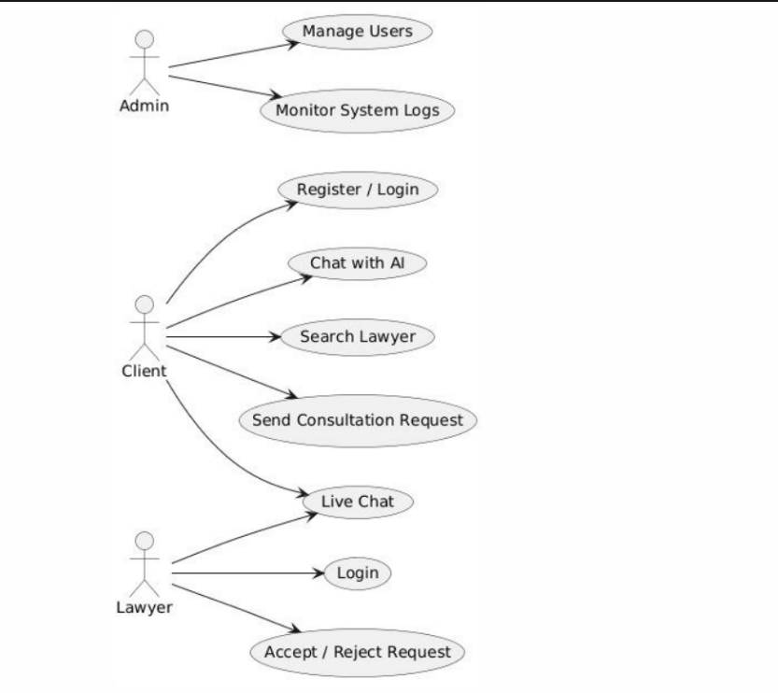
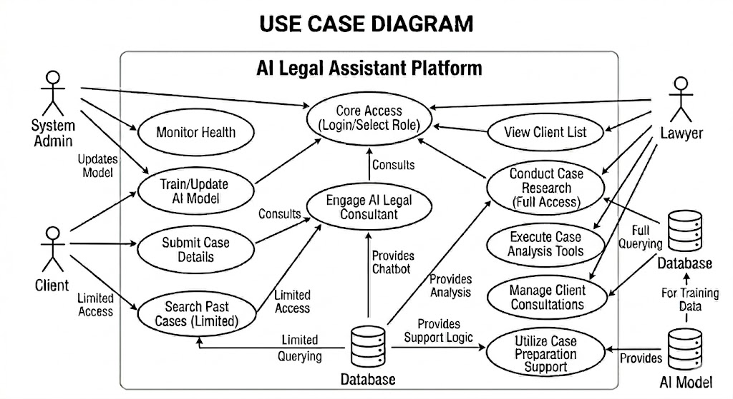

Non-Functional Requirements:

5.1 Performance Requirements
- Chatbot response time should not exceed 3 seconds
- System should handle multiple users simultaneously

5.2 Safety Requirements
- System must prevent misleading or harmful legal information
- Disclaimer must be displayed for AI responses

5.3 Security Requirements
- End-to-end encrypted communication
- Secure authentication mechanisms
- Role-based access control
- Protection against unauthorized access

5.4 Software Quality Attributes
- Reliability: System availability and consistency
- Usability: Simple and intuitive UI
- Scalability: Ability to support more users

5.5 Business Rules
- Only verified lawyers can provide services
- AI responses are for guidance only
- Admin approval required for lawyer accounts

5.6 Interoperability
- Integration with OpenAI API and external services

5.7 Extensibility
- System can be extended to mobile applications
- New legal domains can be added

5.8 Maintainability
- Modular architecture
- Well-documented code

5.9 Portability
- Browser-independent web application

5.10 Reusability
- AI chatbot and authentication modules reusable

5.11 Installation
- Deployed on web server or cloud platform

Other Requirements:

6.1 Online User Documentation and Help System
- User manuals
- Help guides and FAQs

6.2 Purchased Requirements
- OpenAI API services

6.3 Licensing Requirements
- Compliance with open-source licenses

6.4 Legal, Copyright, and Other Notices
- Data privacy and usage policy
- Terms and conditions

6.5 Applicable Standards
- IEEE Software Requirements Specification (SRS) Standard

6.6 Reports
- User activity reports
- Lawyer engagement reports
- System usage summaries

References:

IEEE SRS Documentation

Legal datasets and statutes

OpenAI API Documentation

